**Instructions**

* The duration of this challenge is **120 Minutes**.
* Programming questions have a **Compile and Run** option where you can run your solution against sample test cases before submitting it.
* Click **Evaluate**button only if your code compiles successfully.
* This challenge covers the following topic(s).
* Conditional constructs
* Looping
* Arrays

**Problem: Revenue Share**

Some friends have started an cake shop. All of them have invested certain amount for starting the company. They share the profit **proportionate to the ratio of the shares** they have invested. Given the profit amount and the ratio of shares of the partners’, write a program to find the **amount of profit** that will go to the each of the partner’s and the lowest profit value among the partners.

Create a class called **RevenueShareCalculator** with below methods:

|  |  |
| --- | --- |
| **Method Name** | **Method Description** |
| public bool ValidateMembersCount (int partnersCount) | This method validates whether the number of partners entered is between 2 to 5(inclusive) which is a valid input. If it returns false, print a message **“Invalid Number of Partners Entered..Restart Your Application”** and terminate the application. |
| public bool ValidateProfitAmount (long profitAmount) | This method will check if the company’s total profit entered is greater than or equal to 10000 which is valid input. If it returns false, print a message **“Invalid Profit amount..Restart Your Application”** and terminate the application. |
| public bool ValidateShareValuation (int shareValuation) | This method will check if the company’s share valuation in stock market is between 5 to 20 (Inclusive) which is valid input. If it returns false, print a message **“Invalid Share Valuation in Stock Market Entered..Restart Your Application”** and terminate the application. |
| public bool ValidateNumberOfShares (int partnersCount, int sharesCount) | This method will check if the number of share ratios entered in input is same as number of partners which is the valid condition. If it returns false, print a message **“Invalid Number of Share Ratio Entered..Restart Your Application”** and terminate the application. |
| public bool ValidateRevenueShareRatioValues (int[]shareRatios) | This method will check whether the input array elements are positive or not.If it returns false, print a message **“Negative Share Value Entered..Restart Your Application”** and terminate the application. |
| public bool ValidateRevenueShareRatios (int shareValuation, int[] shareRatios) | This method will check if the sum of share ratios of all partners is equal to company’s share valuation in stock market which is the valid condition. If it returns false, print a message **“Combined Share Ratio of all Partners does not match with Company's Share Valuation in Stock Market”** and terminate the application. |
| public double[] CalculateProfitShareAmount  (long profitAmt, int shareValuation, int partnersCount, int[] shareRatios) | This method will calculate and return the profit share amount of each partner in the partnership |
| public double FindLowestProfitAmount (double[] profitShares) | This method will return the lowest profit amount. |

Create a class called **Program** with main method. Call the **RevenueShareCalculator** class methods under the Program class and test your application.

**Input Format:**

* First line is an integer that denotes the number of partners in the company.
* Second line is an integer that denotes the Total Profit Amount made by the company.
* Third line is an integer that denotes the company’s share valuation in the stock market.
* Fourth line consists of space separated integers that denote the share ratio values of the company’s partners.

**Output Format:**

The output will contain profit amount of each partner and the lowest profit amount rounded to 2 decimal places.

**Hint:**

**Calculation of Profit Amount for each person=**

(Total Profit * Share Ratio)/(Share Valuation)

For example if Total Profit is 78945; share ratio of Mr. A=2, Mr. B=3 and Mr. C= 4 respectively and Share Valuation of the Company in Stock Market is 9 then:

Mr. A Profit Amount= (78945*2)/(9)= 17543.33

Mr. B Profit Amount= (78945*3)/(9)= 26315‬.00

Mr. C Profit Amount== (78945*4)/(9)= 35086.67

**Sample Input / Output1:**

**Sample Input / Output2:**

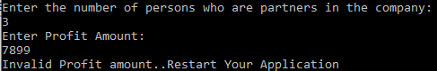

**Sample Input / Output3:**

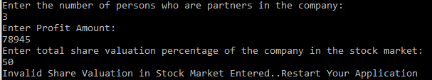

**Sample Input / Output4:**

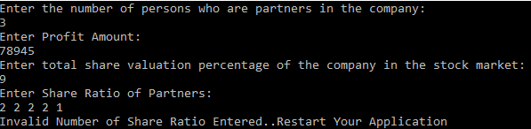

**Sample Input / Output5:**

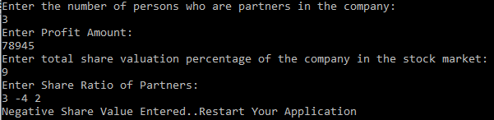

**Sample Input / Output6:**

